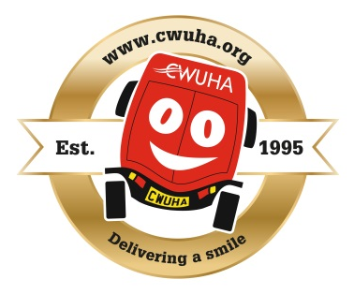
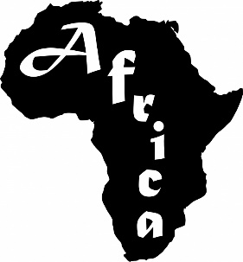

CWUHA Sponsor a Child in Africa
If you wish to sponsor a child in Africa, please complete this form and send it to the address given below with your cheque. We very much appreciate your support.

Gift Aid was introduced by the Government in 1990 and revised in April 2000; it allows charities to reclaim tax on your donations. This is a valuable way of raising income especially as most people pay tax. For example, it allows a donation of £10.00 from you to the CWUHA, to be worth £12.50* approx. The charity does all the work and the only requirement is that you are paying tax at the basic rate. We claim the money back from the Inland Revenue. It doesn’t mean you have to pay extra tax or fill in any additional tax forms. So you will see that this is a simple way of your donation being worth more. *Obviously the example given will alter with any change in the basic rate of tax.

NAME OF INDIVIDUAL: ________________________________________________________________________________________________

ADDRESS: ________________________________________________________________________________________________

________________________________________________________________________________________________

POSTCODE: _____________________ TEL: ______________________________________________

EMAIL: __________________________________________________________________________________________

I want the charity to treat all donations I have made since 6th April 2000, and all donations I make from the date of this declaration until I notify you otherwise as Gift Aid donations.

I wish to DONATE the sum of £_________ to sponsor _____ child/children in Africa payment by Cheque / Bank Transfer.

Please indicate below your preferred methods for us to contact you in the future. Please tick all that apply.

○ Post ○ Telephone ○ SMS/Text ○ E-mail

SIGNATURE: _______________________________________________ DATE: ________________________

Please make cheques payable to ‘CWUHA’ and send with this form to: Paul Newsham CWU, 75 Garstang Rd, Preston, PR1 1LD.

Or you can make a bank transfer to:
Bank: Unity Trust Account name: CWU Humanitarian Aid
Sort Code: 60 83 01 Account Number: 20031169
Reference: Africa Sponsorship.

If paying by BACs please complete this form and send Paul Newsham at the address above.

Notes
- You must pay an amount of income tax and/or capital gains tax at least equal to the tax that the charity reclaims on your donations in the tax year (currently 25% which yields 25p for each £1 you donate).
- You can cancel this donation at any time by notifying us.
- If in the future your circumstances change and you no longer pay tax on your income and capital gains equal to the tax that the charity reclaims, you can cancel your declaration.
- If you pay tax at a higher rate you can clam further tax relief in your Self-Assessment tax return.
- If you are unsure whether your donations qualify for Gift Aid tax relief, ask the charity, or ask your local tax office for leaflet IR 65.
- Please notify us if you change your name or address.

We very much appreciate your support and we can make a difference to children with your help.

Communication Workers Union Humanitarian Aid.

Registered Charity No: 1078312. Head Office: 302a Barlow Moor Rd, Manchester, M21 8AY.
Tel: 0161 881 8118 Email: cwuhaprojectworkers@gmail.com
President: Carl Webb Head of Admin: Steve Rowlands Honorary President: Dave Ward, CWU General Secretary
Patrons: Angela Rayner MP Jude Kirton-Darling Former MEP Alan Johnson Former MP Lord Peter Hain

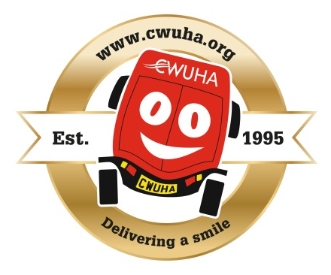
The Communication Workers Union Humanitarian Aid (CWUHA)
Need you to sponsor a child in Africa

Have you ever considered sponsoring a child living in poverty?

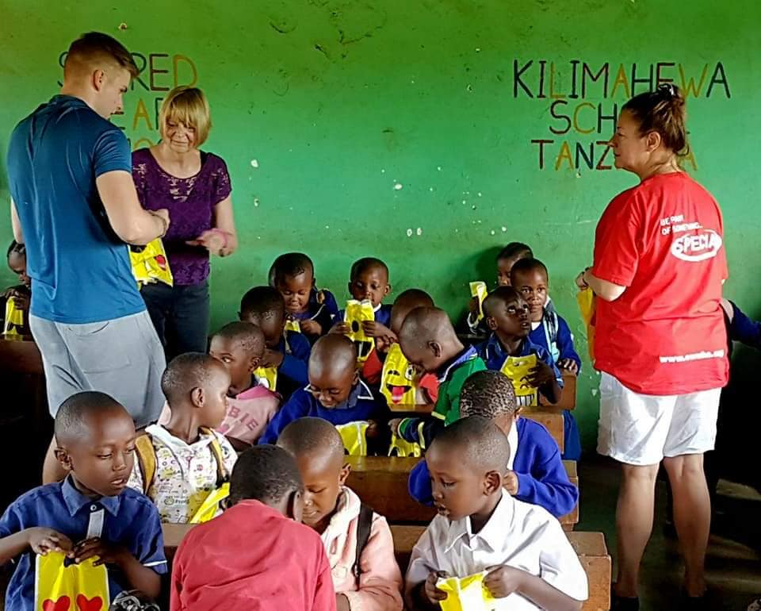
For many years CWUHA has sponsored up to 52 small children each year at a school situated in Kilima Hewa, Moshi, Tanzania, Africa. This early year’s education, teaches small children communication skills and encourages social interaction with other children prior to going into main stream education.

Giving a small child access to education and a meal each day, helps to bring hope and lasting change for that child’s future. These Children can walk many miles just for a chance to learn, play and get a meal.
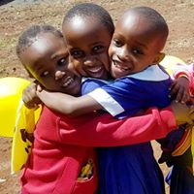
The charity would like to sponsor more children in Moshi, Tanzania and you may be able to help.

At a cost of £40 per child per year, that’s less than the price of four takeaways per year. They each receive two school uniforms per year, they receive a cooked meal each day and at least two fresh eggs per week!

Please consider sponsoring a child today

Complete the form on the back and return to
Paul Newsham CWU, 75 Garstang Rd, Preston, PR1 1LD

For more information about the work that CWUHA do go to www.cwuha.org or scan the QR Code.

