Registered Charity No: 1078312

2019
Trustees Annual Report
and
Accounts

CWUHA
302a Barlow Moor Rd
Chorlton Park
Manchester
M21 8AY
Tel: 0161 8818 118
Email: info@cwuha.org

@cwuha /CWUHA cwuha95 www.cwuha.org

CWU Humanitarian Aid
TRUSTEES REPORT - 2019

Chair's Observations

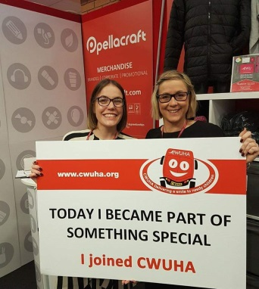
In 2019 we continued to receive amazing support from BT, Royal Mail, An Post and Eir. These companies supply us with vehicles, fuel cards and paid release. Without this support and the assistance we receive from CWU Ireland and the CWU in the UK we wouldn’t be able to deliver smiles in Eastern Europe, Africa and her in the UK.

We also receive fantastic support from many other companies like Pellacraft, Unionline and the union’s panel of solicitors.

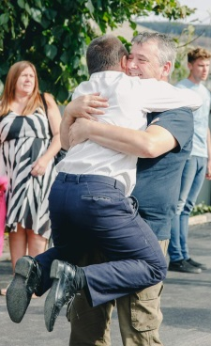
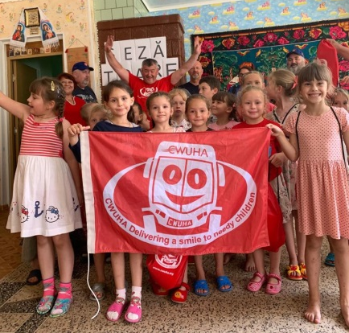
So what happened in 2019? Well to start with working with our partners Mad-Aid we organised two convoys to Moldova. The early convoy made up of 4 vehicles, including one from CWU Ireland was delayed till June to coincide with the opening of phase 2 of the CWU supported Phoenix Centre. The convoy delivered aid to the Phoenix centre, Kindergartens, children’s homes and vulnerable families. We had 3 volunteers traveling for the first time which is always encouraging.

The Sept convoy transported aid in BT and Royal Mail vehicles and visited and delivered aid to the CWU supported Phoenix Disabled Centre in Riscani, Kindergarten in Sipoteni, Community house for children with special needs in Chisinau and a centre for autistic children in Balti.

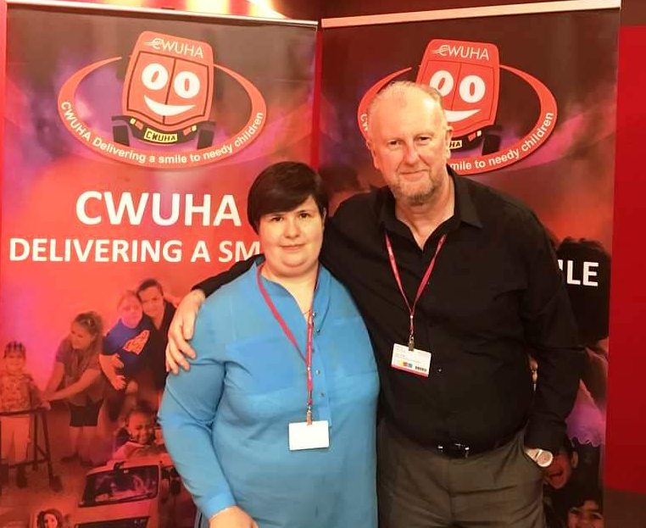
Once again, we held our AGM at the CWU Conference at no cost to the charity. Victoria Dunford, CEO and Founder of our partners Mad-Aid was the guest speaker. Together we have completed many projects, distributed aid across the whole country to hospitals, kindergartens, orphanages and thousands of disadvantaged families. We refurbished the Phoenix Centre – a centre that transforms the lives of children with special needs, organised three football tournaments and provided a holiday of lifetime for 14 Moldovan children. The AGM proved our strong partnership and collaboration - with more to come!
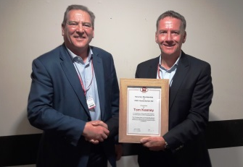
At the AGM Tom Keeney, former BT Director was presented with CWUHA Honorary Membership by Andy Kerr, CWU Deputy General Secretary. This was well deserved - Tom is one of our biggest advocates and attended the opening of the Phoenix centre in 2015.
During annual conference CWU SOC legend Paddy Magill shaved off his celebrated moustache. Once again, our CWUHA barber Paul Moffat was on hand to do the honours.

In 2019 CWU Mid Wales & Marches Branch, members, family & friends, once again raise funds for CWUHA by taking part in the Annual Longmynd. Some true grit & determination was displayed in order that CWUHA can Deliver More Smiles!
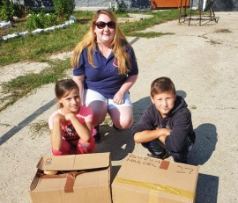
This year CWUHA said hello to their newest trustee – Becky Crook who took part in her first convoy in May 2018 and the trustees were so impressed they invited her to fill a vacancy on the board.

Two CWUHA Trustees Mick Kirkby and Eric Parker traveled to Moldova at their own expense to visit the CWUHA supported Phoenix Disabled Centre run by our partners Mad-Aid. While they are in-country they buy food and household goods for vulnerable families.

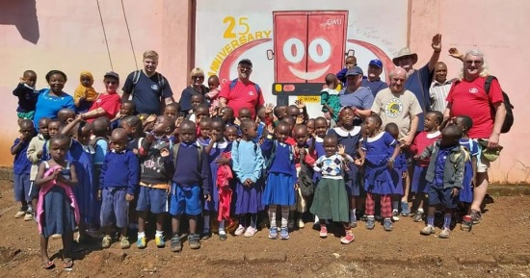
Several CWUHA Trustees and supporters visited Moshi, Tanzania in Nov, in order to review the charity's involvement in Tanzania. While in Tanzania they visited the CWUHA supported school and other needy institutions like the Excel Foundation who support families who can’t afford to put their children through school. They also visited some of the families of the children sponsored by CWUHA. This was a first and in their words “We cannot describe how heart breaking, but also heart-warming this was”.

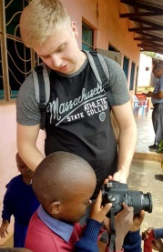
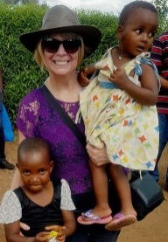
On the trip were mum and son - Julia & Joel Upton. Julia has been a big supporter of the charity for a number of years and had visited the school in Moshie previously.

With the support of CWU members and branches we continue to sponsor 60 children at the school and pay the wages of a teacher. This on-going CWUHA project provides free education and meals for nearly a 100 children. Without this many of these children would go hungry.

When requested we have also supported good causes in the UK and we continue to look for UK projects to get involved with.

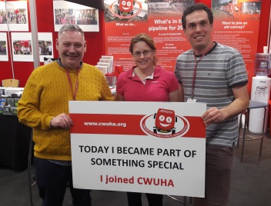
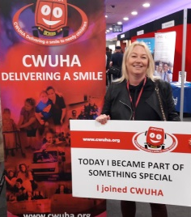
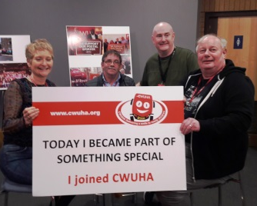
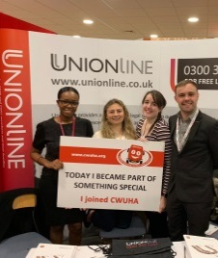
Thanks to a lot of hard work by some trustees, in 2019 we continue to see the numbers of individuals affiliated to CWUHA increase.
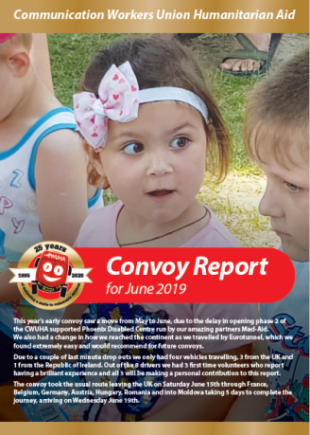
As a charity we work hard to keep our supporters/affiliates as informed as possible via our web site www.cwuha.org set up and hosted by Pellacraft at no cost to the charity. We are also on Facebook /CWUHA twitter @CWUHA and Instagram cwuha95

We also produce convoy and special project reports; have a stall at general conference and other union events.

The charity continues to operate out of the Greater Manchester branch premises, rent free, for which we are thankful.

It would be remiss of me not to mention the unstinting work carried out by our network of unpaid volunteers and trustees across Ireland and the UK. Massive thanks to all of them.

Carl Webb
Chair, of the Trustees

Financial Year 2019 Report

2019 Moldova continues to be our main project the Phoenix Centre which is now complete along with the excellent work being achieved in Tanzania. Moldova which is still the poorest country in Europe and we sent convoys in June & September carrying much needed aid to the most vulnerable. On our visits to Moldova during the financial year we identified more poor families and children who require our much needed help, which will continue through 2020 along with projects in Tanzania. Without your financial support it would be near impossible to carry on as we are today, the generosity of individuals, Branches and Region never ceases to amaze.
Income

1100 – This figure is included within the Tolstoy account below.
1200 – 1210 Monies in the Humanitarian Aid account £17,020.90 & the Tolstoy account £15,154.21 at the end of 2019.
1212 – 1214 Caxton Convoy 1 £3,289.08, Convoy 2 £3,297.09 are Caxton currency cards needed to pay for toll & hotel fees, also purchases that may need to make in the Country we are visiting. Again totals at the end of 2019.
3200 - Funds £21,864.13 at the start of the financial year.
4000 – £16,308.37 4001 £41,101.36 Donations received some of which are gift aided.
4100 – Affiliation from individuals paid annually.
4102 – Affiliations to us from, branches & regions £5,504.00.
4600 – Fund Generation / Fund Raising £450.00.
4800 - Other income - £12596.80 Caxton Card load &Transfer.
4805 – Other income – Charities Trust £6,208.25
4806 – Other income – CAF £12.82
4808 – Other income – Mydonate £3,649.33
4809 – Other income – Paypal giving £48.76.
4810 – Individuals Hotel Fee – Projects/Convoys £1,607.94.
4811 – PO Ferries – Drivers Payments £140.00

Expenditure

5000 - £26,343.13 Humanitarian Aid Projects. 5201 – Convoy Aid Purchased £22,770.56.
5201 – Convoy Aid Purchased £16,404.95.
6202 – Miscellaneous Purchases - £9,225.98, Knitting Supplies, £194.74 Printer for Office £154.98, Caxton card transfer £8,742.32, AD Trotter unpaid cheque £40.00, Entrance fee Mad Aid Ball £93.94.
7202 - Water Rates £595.97
7105 – Electricity £281.60
7202 - £1,474.30 Hotels Convoys & Projects only.
7205 – PO Ferries for Convoys £1,653.12
7206 - £4,200.00 Subsistence Convoys Only
7300 – £76.43 Printing.
7301 - £273.70 Postage.
7303 - £2,200.40 Promotional Goods.
7502 – £54.35 Laundry.
7504 - £240.00 Miscellaneous Motor Expenses.
7505 – £537.37 Vehicle Fuel.
7508 - £189.31 Congestion Charges-Road Tolls.
7605 – £29.01 Refreshments.
7606 – £3840.52 Caxton Cards Top up incorrectly categorised.
7701 – £240.84 Bank Charges for transferring monies to Tanzania-Moldova.
7904 - £86.40 Security Checks.
7809 - £83.95 Adjustments due to fluctuations in currencies.

We finished the financial year with £38,761.28 in all accounts including Caxton Cards, We have successfully meet our commitments in Tanzania – Moldova, with two convoys in May & again in September along with giving help when asked un UK, none of this could be achieved without your continuing support, as you can see by our accounts unlike other charities our admin cost have been and will always be kept to a minimum.. I thank every individual who affiliates every month to our charity along with Branches and Regions. I would also like to thank our friends in Ireland our Convoy Drivers, Royal Mail & BT & Victoria Dunford Mad-Aid for their continuing support.

Please continue your fantastic support for this excellent charity over the coming years.

Eric Parker - CWU HA Financial Officer

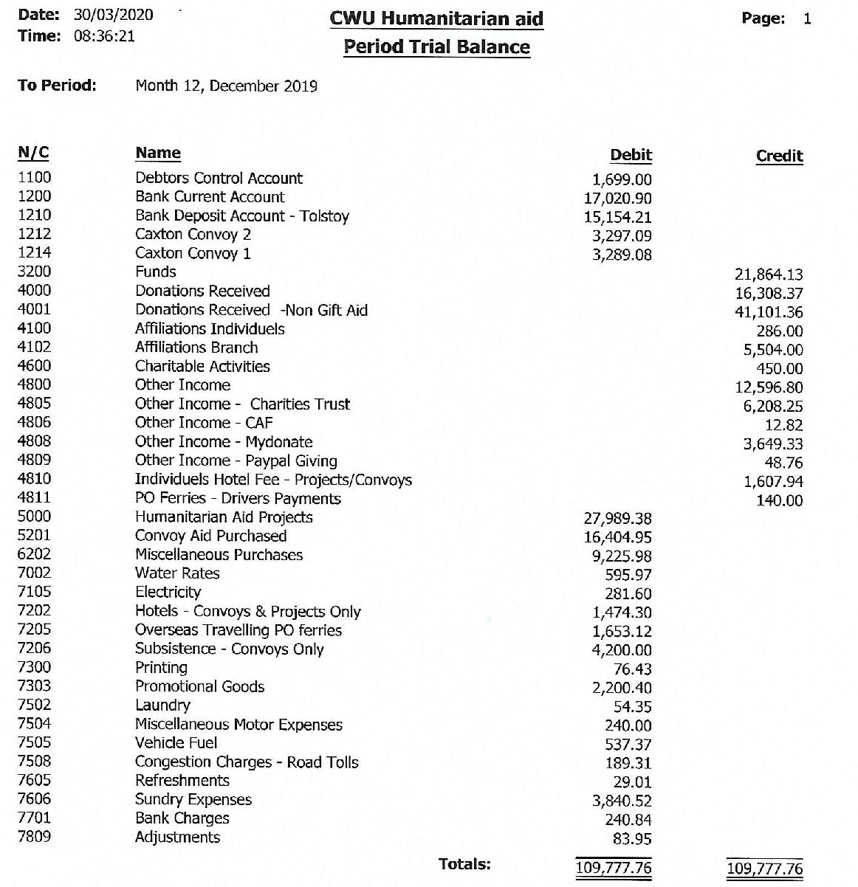
2019 CWUHA Project Workers Reports

CWUHA Africa Report

During 2019 CWUHA continued to support a school in Moshi Tanzania. The school which is run by the Head Master, Mr. Massawe, at his family farm, now is able to offer vitally needed education for up to 100 poor village children, on a daily basis. An education, which was previously denied to them.

The children receive their education in five schoolrooms. CWUHA provided the finance over several years for the school rooms to be constructed, plus toilet facilities.

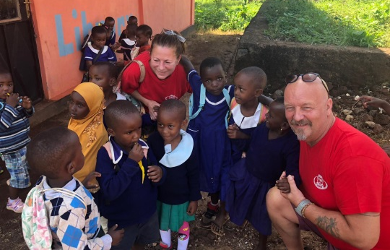
Alongside the school is a specially adapted room which houses 200 chickens. The eggs that the chickens lay not only provide funds to help purchase the school’s needs but also supplements the daily bowl of maize porridge which Susan, the wife of the Head Master, serves to the attending children. This is one meal per day that the kids may not have received at home.

With the help of CWU branches and individuals, the charity was able to pay for the education, school uniforms, and the daily meal for 40 children in 2019. In order for all the school rooms to be fully utilised a second teacher was required. CWUHA paid the annual salary for the teacher Lucas. School supplies were purchased and fencing erected to make the school grounds secure from vandals and scavenging animals.

CWUHA provided funds for the installation of electricity which enabled Mr. Massawe to open the school in the evenings so that the older children, who had to work to support their families, could receive some long overdue education. A library building was erected in order to house 8000 books previously donated by an American charity.

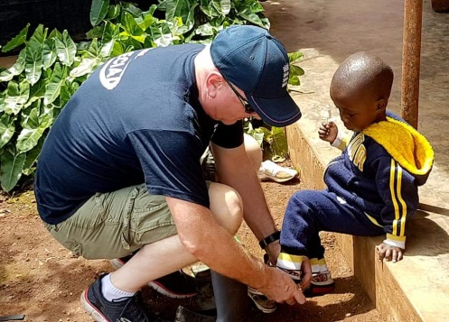
Volunteers are encouraged to travel to Moshi for two weeks, once again at their own expense, to act as teaching assistants in order to help with the education of the children. Previous teaching experience was not essential. Their main contribution was to offer TLC and to spend time with individual children giving them the opportunity to practice their English, which is vital for these kids to get out of the poverty trap by gaining employment in the tourist industry.

Several CWUA Trustees visited Moshi in November 2019, in order to review the charity's involvement in Tanzania. They visited the school and other needy institutions. A full report of this visit can be found on at the end of this report.

We hope to be able to continue this great work in 2020 and beyond.

WE NEED YOUR CONTINUING HELP AND SUPPORT

CWUHA June 2019 Convoy

From early January through to mid-June the emails are exchanging at a rapid rate for the May convoy. From contacting royal mail regarding the vehicles, Victoria Dunford (our in country partner for Moldova) regarding the wish lists to the convoy drivers to feed them information and respond to their enquiries. Once everything is in place it’s a case of monitoring the convoy, making sure all aid is delivered, everyone returns safely and the vehicles are returned to Royal Mail, hopefully undamaged. Then it’s take a deep breath and start the process all over again for the September convoy.

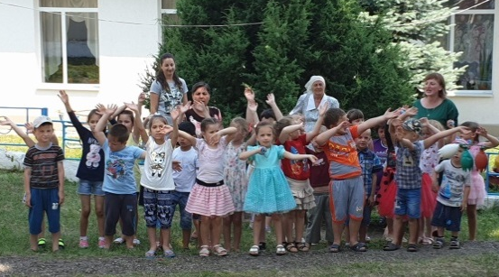
2019 was unusual for a couple of reasons. The early convoy which usually takes place in May was moved to June to coincide with the opening of phase 2 of the Phoenix Centre and convoy was small in comparison most years with only 4 vehicles travelling to Moldova including a vehicle the Republic of Ireland driven by volunteers from the Irish CWU. The convoy delivered aid to the Phoenix centre, Kindergartens and vulnerable families. We had 3 volunteers traveling for the first time which is always encouraging.

Below are comments made by the new volunteers on their return to the UK and Ireland.

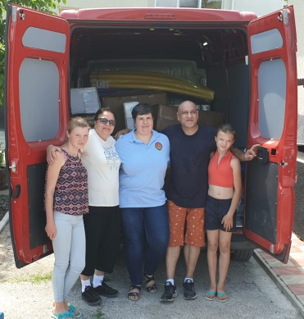
“I felt the convoy was well organised and team leaders had good knowledge of the whole journey to and from Moldova. Good drivers in the convoy and all had a laugh.
The whole experience at the Phoenix centre was priceless and the memories will last a lifetime. To see the kids smiling and laughing and full of joy was also a heartfelt highlight of the convoy.
CWUHA a BIG thanks for giving me this opportunity to be a part of this Convoy.

Parminder Sethi
Royal Mail.”
---------------------------------------------------------------------------------------------------
"Words can never describe a Convoy Experience...
I had been an admirer of CWUHA for many years and have been a member for a while now. Having attended previous AGM's and stood in awe at the good work that the charity does, little did I know that I would be a convoy driver experiencing the incredible uplifting and inspiring events of CWUHA's June Convoy to Moldova.
There are many highs - so many to list individually. But the opening of the new block at the Phoenix Centre was truly a special day. As a regular visitor to Calais and Dunkirk (assisting refugees) I have witnessed many inspiring and difficult scenarios but this was very different.
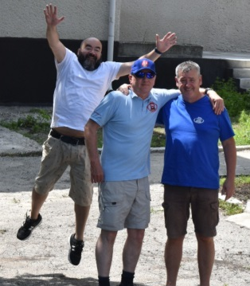
The experience has seen new friendships forged and existing friendships strengthened. My horizons have been broadened in a way I thought not possible.
One of the big things about this charity, which is clear to see, is that the aid gets taken to exactly where it is needed - there is no 'middle-person' and so I had the benefit of seeing those smiles first hand, which is priceless.
I had a lot of banter with the team, which when you are driving for up to 10 hours a day you need, otherwise your sanity is pushed to the limits. Steve was a great convoy partner - a fabulously experienced driver and the perfect co-driver for me.
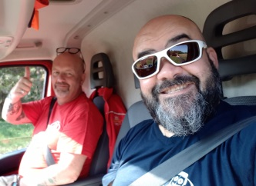
In closing, a special mention to our friends at CWU Ireland, Mick and Eamonn. A wonderful friendship was forged. By the end of the fortnight Mick was calling me son - and I was calling him dad (the rest of the convoy called me mini-Mick!).
For the record I would like to thank CWUHA for allowing me this opportunity and also to the CWU for their support in facilitating my request. It might be a bit cliché, but genuinely, words can never quite describe a convoy experience. I expect this will not be my last convoy!
Fevzi Hussein – Newbie, CWU HQ
---------------------------------------------------------------------------------------------------
“I left Moldova with a sense of pride and satisfaction”
It was always in my mind to take part in a CWUHA convoy to Moldova but I was always a bit apprehensive. However, after talking to Mick, and Joe who travelled on last Septembers convoy, the advice and support they gave me was invaluable. So I decided to give it a go and now I’m delighted I got accepted as it was one of the most rewarding experiences of my life.
It was pretty hectic before we left raising funds, asking for sponsorship and filling the wish list but I could be with no better man than Mick Walsh. I learned pretty quickly if you don’t ask you won’t get and I have to thank all the generous donors who sponsored me and also the invaluable help and assistance from Pascal Connolly & Jimmy o Connor and all the staff at CWU HQ in Dublin
Heading off on that Saturday morning, catching the ferry and driving through North Wales I was pretty nervous but when I met Lenny & Steve our convoy leaders at service station on the m6 I was put pretty much at ease with their good humour and professionalism. Then when I met the rest of the Drivers at the channel tunnel I knew that we had a great team heading to Moldova.
Driving down through central Europe was pretty uneventful but with temperatures in the high 30’s my co driver was the most chilled out driver I have ever travelled with. It was very impressive how the convoy led by Lenny and Steve organised fuel stops, meal breaks, paid tolls, booked hotels and dealing with customs etc.
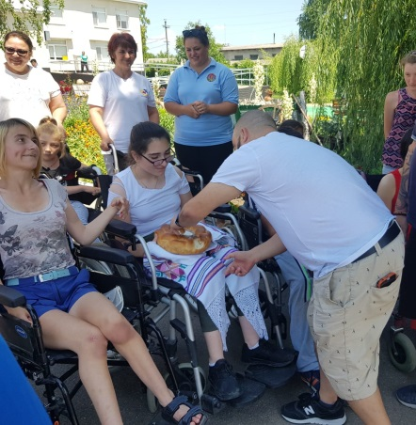
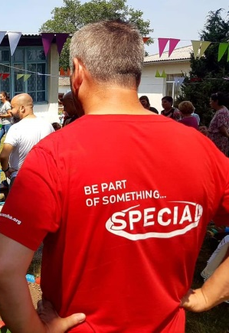
When we arrived in Moldova I was pretty shocked at the state of the infrastructure, the roads especially were pretty horrendous and when driving out to the phoenix centre I could not believe the state of the road down to the centre which was in sharp contrast to the centre itself which stood out like a beacon of hope. It was very impressive and is a testament to all the good work carried out over the years by the CWUHA and others to bring it to its current state. The welcome we received from the children and staff was heart-warming and unforgettable. It was great to see at first hand all the aid being delivered to the Center, kindergarten and vulnerable families. The new wing for the old folk’s home was also very impressive and it will be great to see a blend of young and old at the centre where one can learn off the other.
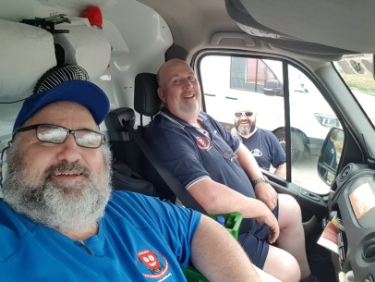
I left Moldova with a sense of pride and satisfaction for what the convoy had achieved. Also a sense of companionship with my fellow colleagues and I hope that we keep in touch as this was a great team and everyone played a part in bringing a smile to many faces. I hope to support this worthy cause for many years to come
Regards
Eamonn CWU Ireland.
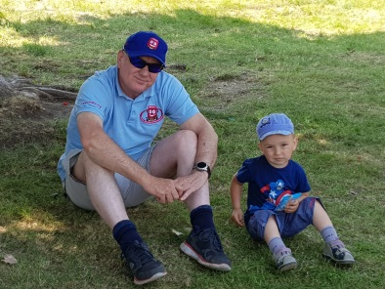
I think you’ll agree that the comments above say it all.

Lenny Crook
CWUHA Project Worker

CWUHA September Convoy 2019

We continue to work with MAD Aid charity; this is since 2015, when the ‘Phoenix Centre’ officially opened, in the village of Riscani, North Moldova.

In 2018, the CWUHA committee and trustees, discussed a long-term strategy for the charity and agreed to maintain a further 2 convoys to visit Moldova in May and September 2019, supporting the functioning of ‘Phoenix Centre’ and to provide essentials to the most recent addition; the self-sustainable Disability Hospital.

It is planned that the Disability Hospital will be self-supporting through the charging of clients; this money will also be used to help fund the ‘Phoenix Centre’ in the view of providing a long-term future for both centres. The opening launch ceremony was held in September 2019. Were some CWUHA trustees attended on a self-funded basis. The convoy drivers, provided essentials for the building, such as radiators, toilets, sinks etc.
The September 2019 convoy was made up of 4 vehicles; the drivers are employed by BT and Royal Mail

Arriving in Moldova on the 16th of September 2019 – the drivers visited and delivered aid to the following;

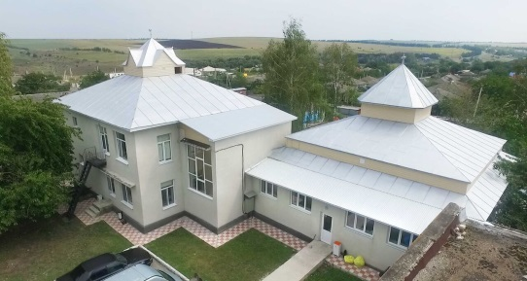
Phoenix Centre; the aid consisted of routine items to enable the upkeep of phase one, primarily essential items such as hygiene products, household necessities. Along with this, the HA provided equipment for the treatment of physical ailments and language therapy, such as massage & aromatherapy items. As well as wheelchairs and bedroom furniture.

Phase 2; is now completed and is the first ‘Model Centre’ for elderly and disabled people in Moldova. Some CWUHA trustees attended the launch ceremony on a self-funded basis.

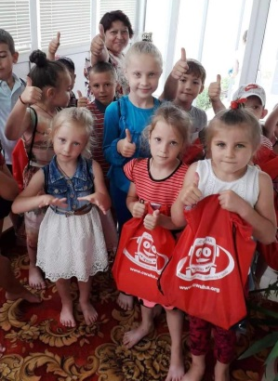
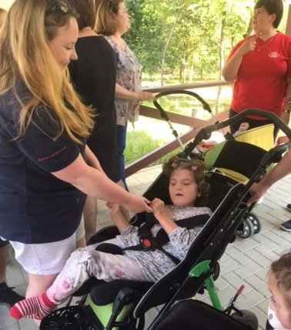
Sipoteni, Calarasi Sipoteni Kindergarden; aid provided by the HA, included vitally needed kitchen equipment for the centre. Along with educational materials and clothes for the children.

Bacioi village and Comunitry house for children with special needs in Chisinau. Again the provision of clothes and esentials were provided.
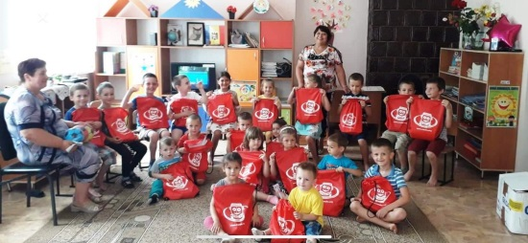
SOS Autism centre is the centre for autistic children in Balti, were we provided essentials such as clothes, bedding, kitchen & hygiene essentials & children’s toys.

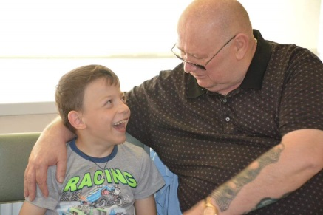
Extra cash was raised of around £4000.00 by Eric, this was used in country to purchase items needed by vulnerable families. Other items such as food and large electrical equipment was bought in country, and delivered by the drivers, directly to the centres or to the families.

Trish Vollans
CWUHA Project Workers

CWUHA visit to Tanzania
November 2019

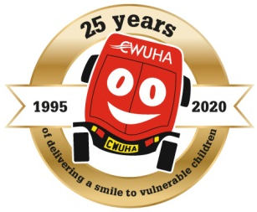

The trustees visited Tanzania on a joint mission, firstly to check on the progress of our sponsored school and secondly to look at the possibility of supporting other projects.

The economy of Tanzania is the second largest in East Africa and tenth largest on the continent. Tanzania, despite its natural resources, remains one of the most impoverished countries in the world with 36% of its population living below the poverty line (21 million people). The average take home earning is 32,080 Tanzanian shillings (£12.33 per month), however the most typical take home salary is 7800 Tanzanian shillings which is around £3 per month.

Kilimahewa School
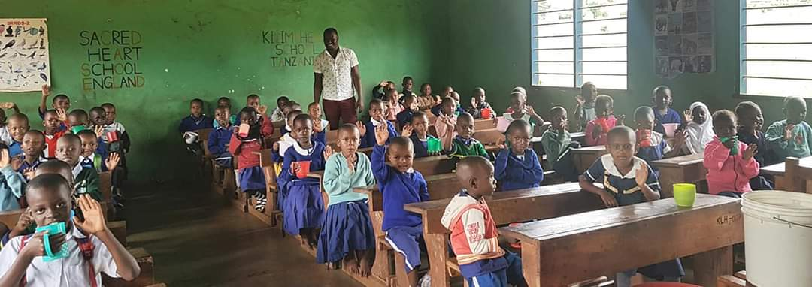

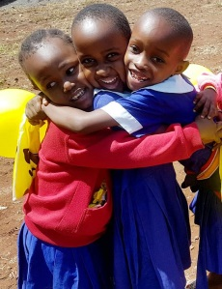
The Kilimahewa School has changed little since the last visit in that it is still basically a nursery school, providing early learning for around 85 children. CWUHA has supported the school for over ten years and presently fund school uniforms and meals for over 50 children as well as teacher’s salary. Mr Massawe the founder and Head teacher assured us that it was still his goal to take the school to the next level of education but that this was a slow process involving many inspections from the education department and at significant costs. Each inspection costs 75000 Tanzanian shillings (around £26) per inspector and with usually 5 turning up for each inspection and 5 or 6 inspections a year, the figures soon mount up.

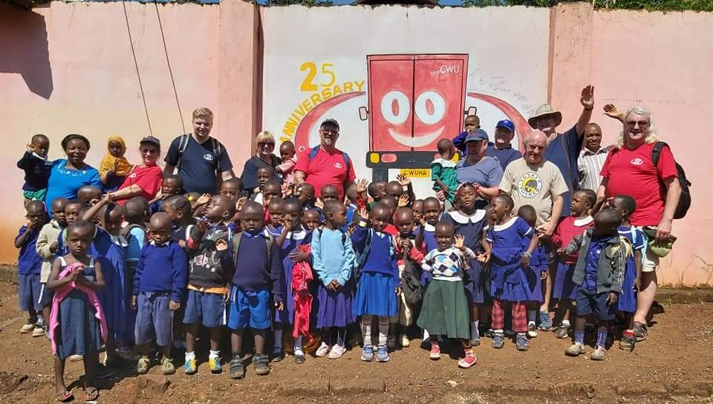
Mr Massawe informed us that once the school receives the certificates required to move to the next level of education, it would have to start charging for pupils to attend to cover the teacher’s salary. On a positive note Mr Massawe informed us that around 80% of children from the Kilimahewa School move onto the next level of education, though this is undocumented.

The children looked well, were very happy and well behaved. We witnessed them being taught Basic English and maths, which they performed with little or no difficulty. They are obviously very happy at the School and are receiving the necessary skills to help in the next level of education.
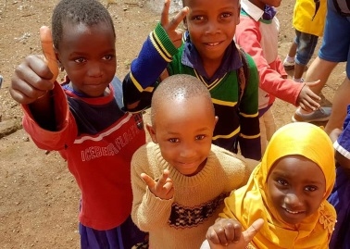
The trustees have reaffirmed their commitment to the Kilimahewa School and will carry on sponsoring children’s uniforms, books, meals and one of the teacher’s salary for the next 12 months.

The other projects we visited are listed below. The overriding theme of these projects was helping underprivileged children mostly through ensuring they received an education.

The BAHA Foundation

The BAHA foundation is an organisation started by two former street kids who now run a successful project offering assistance to other street children. The foundation is run on donations of both cash and food and allows them to ensure the children receive an education along with healthcare, clothing and food.

The foundation also takes time to research the children to see if they have any family in the area they can be either reconciled with or to at least allow them to remain in contact.

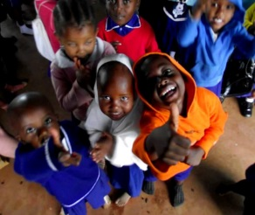
CWUHA has agreed to sponsor the education, healthcare, clothing and food for two children in the care of ‘The BAHA Foundation’.
The Excel Foundation

Similar to the BAHA Foundation but is run by two ladies and helps underprivileged children with their education. The foundation has two facilities, one in Moshi and the second in Arusha. They are inspected by government officials on regular intervals.

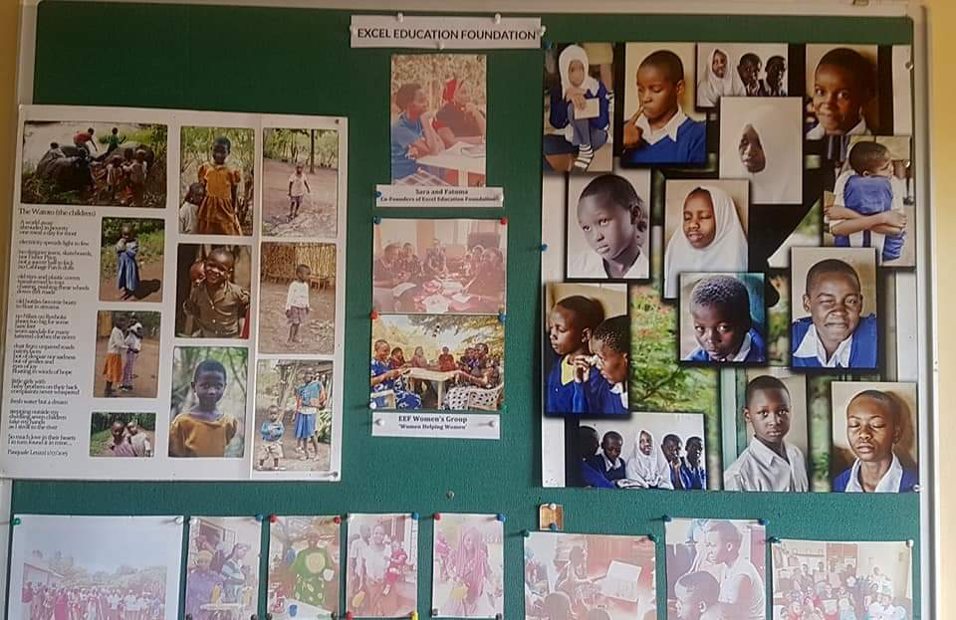
Each student signs a contract of commitment and behavioural standards and they are expected to achieve at least a grade B. They have women from the community teaching life skills to the students which includes cooking and personal finance. 70% of the children live in homes with no electricity so the foundation provides solar lights so they can continue their studies at home.
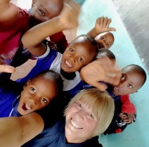
CWUHA has agreed to sponsor the education of two
of the students in the care of The Excel Foundation

Green Pastures Open School

Includes the Matumaini Child Care Centre. Located just outside Moshi it provides for around 35 children, predominantly AIDs victims aging from 7 – 17. The Green pastures open school provides education opportunities for underprivileged and homeless children. Their goal is to provide quality, reliable and sustainable education to the marginalised groups such as girls and the most vulnerable children whose parents or guardians cannot afford to pay the school fees. They also provide support for children who struggle with education.

Share Tanzania
This project supports families with their children’s education, supports street kids and cares for disabled children. It was very obvious during the visit that it brought back memories for a couple of the trustees who had taken part in the early CWUHA convoys. Many of the children are abandoned, some are evicted from the family homes along with their mothers as it is considered bad luck to have a disabled child.

The facility has a number of small chalets were parents can live with their children, allowing them to work while the child is cared for at the centre.
Below is a passage from their web page.

Share Tanzania operates in rural Tanzania, in the foot hills of Mount Kilimanjaro. We began in 2014 from humble beginnings.
Here at ShareTanzania we believe that a solution to many of the issues we see ourselves and others facing on earth, lay in the simple action of sharing. Sharing our time, resources, love and ideas can help to heal a great deal in this world.
Our Mission Statement is clear, to ensure children in crisis find a safe, and loving home.
The main focus of our work is in keeping children with families in Tanzania wherever possible, with a children’s fund supporting over a 1000 children, we are indeed thankfully achieving that goal.

CWUHA Trustees have given the green light to enter into a three year agreement with ‘Share Tanzania’ to make them one of our CWUHA supported projects with a goal to help build a purpose built centre for the care of special needs children.

It is very difficult to not be impressed with all the organisations we visited. Each of them dedicated to helping vulnerable children, not necessarily disabled or abandoned, with in some cases just poverty preventing them gaining an education. Witnessing their achievements is truly inspirational, it’s a real pity we cannot help all of them.

Lenny Crook
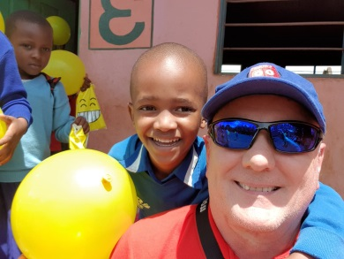
CWUHA Trustee

