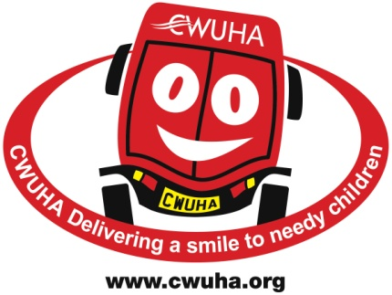

AFFILIATION FORM
If you wish to become affiliated to the CWUHA, as a Union branch, please complete this form and send it to the address given below. We would very much appreciate your support.

BRANCH & REGIONAL AFFILIATION

NAME OF BRANCH/REGION:

________________________________________________________________________________________

SECRETARY: __________________________________________________________________________

ADDRESS: ______________________________________________________________________________

________________________________________________________________________________________

POSTCODE: _____________________________ TEL: _____________________________________

EMAIL:________________________________________________________________________________

If you wish to pay monthly by BACs or set up a direct debit our bank details are:
Bank: Unity Trust Sort Code: 608301 Account Number: 20031169

0 – 400 MEMBERS = £5.00 per month | 401 – 1,000 MEMBERS = £8.00  per month | 1,001 – 2,000 MEMBERS = £11.00 per month
2,000 + MEMBERS = £13.00  per month | Regional Committees = £13.00  per month

If you wish to pay by cheque, please make it payable to: CWUHA and send with this form to: Paul Newsham, CWU Office, 75 Garstang Rd, Preston, PR1 1LD

0 – 400 MEMBERS = £60.00 | 401 – 1,000 MEMBERS = £100.00 | 1,001 – 2,000 MEMBERS = £135.00
2,000 + MEMBERS = £160.00 | Regional Committees = £160.00

SIGNATURE:___________________________________ DATE:____________________________

We very much appreciate your support and we can make a difference to children with your help.

Communication Workers Union Humanitarian Aid
Registered Charity No: 1078312
Head Office: 302a Barlow Moor Rd, Chorlton Park, Manchester, M21 8AY
Tel: 0161 881 9450 Fax: 0161 881 9452 Email: info@cwuha.org
Chair: Carl Webb Financial Officer: Eric Parker Honorary President: Dave Ward, CWU General Secretary
Patrons: Lord Peter Hain, Jude Kirton-Darling MEP, Lord Tom Saywer, Alan Johnson (former MP)

