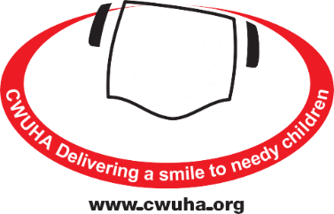
SPONSORSHIP & GIFT AID
DECLARATION FORM
Communication Workers Union Humanitarian Aid
Registered Charity Number: 1078312
Head Oﬃce: 302a Barlow Moor Road,
Chorlton Park, Manchester, M21 8AY
Telephone: 0161 881 8118
Email: info@cwuha.org
SHEET: _________ OF: _________
Gift Aid was introduced by the Government in 1990 and revised in April 2000; it allows charities reclaim tax on your dominations. This is valuable way of raising income especially as most people pay tax. For example, it allows a donation of £10.00 from you to the CWUHA, to be worth £12.50*. The charity does all the work and the only requirement is that you are paying tax at the basic rate. We claim the money back from HMRC. It doesn't mean you have to pay extra tax or ﬁll in any additional tax forms. So, you will see that this is a simple way of your domination be worth more.
*Obviously the example given will alter with any change in the basic rate of tax.
Title | Initial | House Name/Number | Postcode | Date of Donation | Your Donation | Gift Aid  (please tick)
TOTAL
Notes
- You must be a UK taxpayer; the charity can then reclaim the basic rate of tax on your gift - that's a whopping 25p for every £1 you give.
- You can cancel this donation at any time by notifying us.
- If in the future your circumstances change, and you no longer pay tax on your income and capital gains equal to the tax that the charity reclaims, you can cancel your declaration (See note 1).
- If you pay tax at a higher rate you can clam further tax relief in your Self-Assessment tax return. If you are unsure whether your donations qualify for Gift Aid tax relief, ask the charity, or contact HMRC.
- If you are unsure whether your donations qualify for Gift Aid tax relief, ask the charity, or contact HMRC.
- Please notify us if you change your name or address.

We very much appreciate your support and we can make a diﬀerence to children with your help.
www.cwuha.org
Chair: Carl Webb Financial Officer: Eric Parker Honorary President: Dave Ward CWU General Secretary
Patrons: Alan Johnson (Former MP), Judith Kirton-Darling MEP, Sir Anthony Clarke, Lord Tom Sawyer
Registered Charity No: 1078312. Head Oﬃce: 302a Barlow Moor Rd, Chorlton Park, Manchester, M21 8AY.
Tel: 0161 881 9450 Email: info@cwuha.org

