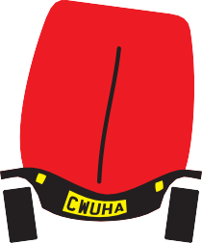
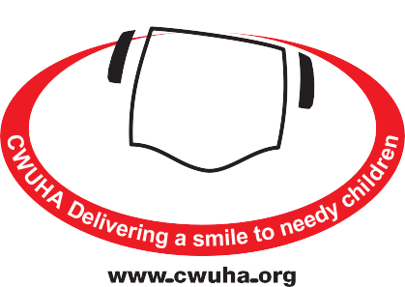
GIFT AID DECLARATION FORM
If you wish to become aﬃliated to the CWUHA, as an individual,
please complete this form and send it to the address given below.
We would very much appreciate your support.
Communication Workers Union Humanitarian Aid
Registered Charity Number: 1078312
Head Oﬃce: 302a Barlow Moor Road,
Chorlton Park, Manchester, M21 8AY
Telephone: 0161 881 8118
Email: info@cwuha.org
Donation Form / Individual Affiliation / Gift Aid Declaration
Name: _______________________________________________________________________________________
CWU Branch: ________________________________________________________________________________
Address: ____________________________________________________________________________________
______________________________________________________________________________________________
Postcode: ____________________________________Tel: ___________________________________________
I want the charity to treat all donations I have made since 6th April 2000, and all donations I made from the date of this Declaration, until I notify you otherwise as Gift Aid donations.
I will donate the sum of £ _________________
Signature: ________________________________________ Date: _____________________________
Please make cheques payable to: CWUHA
Notes
- You must be a UK taxpayer; the charity can then reclaim the basic rate of tax on your gift - that's a whopping 25p for every £1 you give.
- You can cancel this donation at any time by notifying us.
- If in the future your circumstances change, and you no longer pay tax on your income and capital gains equal to the tax that the charity reclaims, you can cancel your declaration (See note 1).
- If you pay tax at a higher rate you can clam further tax relief in your Self-Assessment tax return. If you are unsure whether your donations qualify for Gift Aid tax relief, ask the charity, or contact HMRC.
- If you are unsure whether your donations qualify for Gift Aid tax relief, ask the charity, or contact HMRC.
- Please notify us if you change your name or address.

We very much appreciate your support and we can make a diﬀerence to children with your help.
www.cwuha.org
Chair: Carl Webb Financial Officer: Eric Parker Honorary President: Dave Ward CWU General Secretary
Patrons: Alan Johnson (Former MP), Judith Kirton-Darling MEP, Sir Anthony Clarke, Lord Tom Sawyer
Registered Charity No: 1078312. Head Oﬃce: 302a Barlow Moor Rd, Chorlton Park, Manchester, M21 8AY.
Tel: 0161 881 9450 Email: info@cwuha.org

