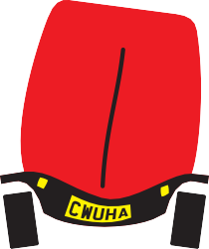
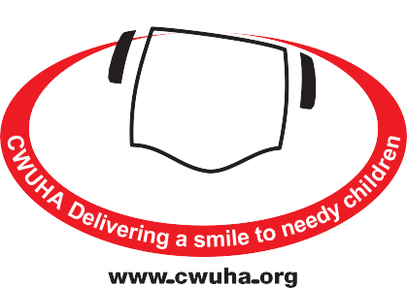
CONVOY VOLUNTEER
FORM
If you wish to take part in a CWU Humanitarian Aid convoy, please
complete the details below and return these along with your business
plan to: CWUHA, 302a Barlow Moor Rd, Manchester, M21 8AY
or email: info@cwuha.org
VOLUNTEER PERSONAL DETAILS
First Name(s): (As detailed on Passport): _________________________________________
Last Name: (As detailed on Passport): ___________________________________________
Place of Birth: ______________________________________________________________
Address: __________________________________________________________________
__________________________________________________________________________
Postcode: ____________________________ Date of Birth: __________________________
Home Phone: _________________________ Mobile Phone: _________________________
Email: _____________________________________________________________________
Emergency Contact Name: ____________________________________________________
Emergency Contact Phone: ____________________________________________________
Employer/Business: ____________________________ Work Phone: __________________
Work Location: _____________________________________________________________
Driving Licence No: ___________________________ Date Passed Driving Test: __________
Type of Licence Held (Car, HGV, etc.): ____________________________________________
Do You Hold a CPC Card? _____________ Do You Have a Digi-Tacho Card? ______________
Do you drive vehicles for Royal Mail/British Telecom? _______________________________
Nationality: ___________________________________ Passport No: __________________
Date of Expiry: _________________________________ Date of Issue: _________________
Issuing Authority: ____________________________________________________________
Signature: __________________________________________ Date: ___________________

We very much appreciate your support and we can make a diﬀerence to children with your help.
www.cwuha.org
Chair: Carl Webb Financial Officer: Eric Parker Honorary President: Dave Ward CWU General Secretary
Patrons: Alan Johnson (Former MP), Judith Kirton-Darling MEP, Sir Anthony Clarke, Lord Tom Sawyer
Registered Charity No: 1078312. Head Oﬃce: 302a Barlow Moor Rd, Chorlton Park, Manchester, M21 8AY.
Tel: 0161 881 9450 Email: info@cwuha.org

