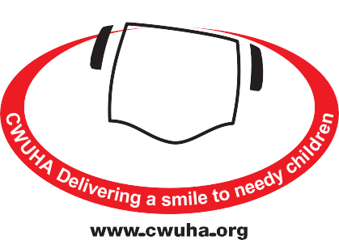
AFFILIATION FORM
If you wish to become aﬃliated to the CWUHA, as a Union
branch, please complete this form and send it to the address
given below. We would very much appreciate your support.
Communication Workers Union Humanitarian Aid
Registered Charity Number: 1078312
Head Oﬃce: 302a Barlow Moor Road,
Chorlton Park, Manchester, M21 8AY
Telephone: 0161 881 8118
Email: info@cwuha.org
BRANCH & REGIONAL AFFILIATION
Name of Branch/Region: ___________________________________________________________________
_____________________________________________________________________________________________
Address: ____________________________________________________________________________________
_____________________________________________________________________________________________
Postcode: ________________________________ Secretary: _______________________________________
Tel: ______________________________ FAX: _________________________________________
Email: __________________________________________________________________
Please Enclose the Appropriate Annual Affiliation Fee (See Below)
0-400 MEMBERS = £50.00 401-800 MEMBERS = £95.00 801-2,000 MEMBERS = £125.00
2,000+ MEMBERS = £150.00 Regional Committees = £150.00
Signature: _________________________________________________________ Date: ___________________
Please make cheques payable to: CWUHA or BACS transfer: Unity Trust, Sort Code: 608301, Account No: 20031169

We very much appreciate your support and we can make a diﬀerence to children with your help.
www.cwuha.org
Chair: Carl Webb Financial Officer: Eric Parker Honorary President: Dave Ward CWU General Secretary
Patrons: Alan Johnson (Former MP), Judith Kirton-Darling MEP, Sir Anthony Clarke, Lord Tom Sawyer
Registered Charity No: 1078312. Head Oﬃce: 302a Barlow Moor Rd, Chorlton Park, Manchester, M21 8AY.
Tel: 0161 881 9450 Email: info@cwuha.org

